**PIZZA SALES SQL QUERIES**

**A. KPI’s**

**1. Total Revenue:**

SELECTSUM(total_price)AS Total_Revenue FROM pizza_sales;

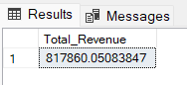

**2. Average Order Value**

SELECT(SUM(total_price)/COUNT(DISTINCT order_id))AS Avg_order_Value FROM pizza_sales

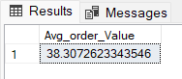

**3. Total Pizzas Sold**

SELECTSUM(quantity)AS Total_pizza_sold FROM pizza_sales

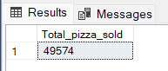

**4. Total Orders**

SELECTCOUNT(DISTINCTorder_id)AS Total_Orders FROM pizza_sales

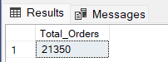

**5. Average Pizzas Per Order**

SELECTCAST(CAST(SUM(quantity)ASDECIMAL(10,2))/

CAST(COUNT(DISTINCTorder_id)ASDECIMAL(10,2))ASDECIMAL(10,2))

AS Avg_Pizzas_per_order

FROM pizza_sales

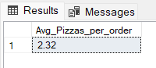

**B. Daily Trend for Total Orders  
SELECT TO_CHAR(ORDER_DATE,'DY') AS DAYS ,COUNT(DISTINCT ORDER_ID)AS ORDERS FROM PIZZA GROUP BY TO_CHAR(ORDER_DATE,'DY')**

**ORDER BY COUNT(DISTINCT ORDER_ID) ASC**

***Output:***

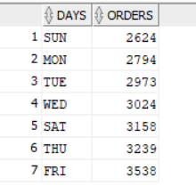

**C. Monthly Trend for Orders**

**SELECT to_char (order_date,'MON') AS MONTHS,COUNT(DISTINCT ORDER_ID) AS ORDERS FROM PIZZA GROUP BY to_char(order_date,'MON')**

**ORDER BY COUNT(DISTINCT ORDER_ID) ASC**

***Output***

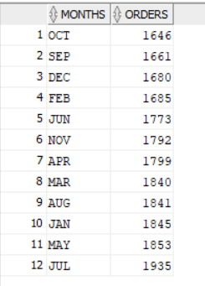

**D. % of Sales by Pizza Category**

SELECT pizza_category,CAST(SUM(total_price)ASDECIMAL(10,2))as total_revenue,

CAST(SUM(total_price)* 100 /(SELECTSUM(total_price)from pizza_sales)ASDECIMAL(10,2))AS PCT

FROM pizza_sales

GROUPBY pizza_category

***Output***

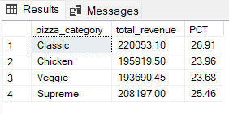

**E. % of Sales by Pizza Size**

SELECT pizza_size,CAST(SUM(total_price)ASDECIMAL(10,2))as total_revenue,

CAST(SUM(total_price)* 100 /(SELECTSUM(total_price)from pizza_sales)ASDECIMAL(10,2))AS PCT

FROM pizza_sales

GROUPBY pizza_size

ORDERBY pizza_size

***Output***

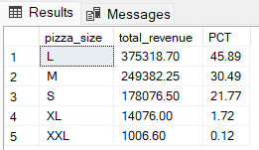

**F. Total Pizzas Sold by Pizza Category**

SELECT pizza_category,SUM(quantity)as Total_Quantity_Sold

FROM pizza_sales

WHEREMONTH(order_date)= 2

GROUPBY pizza_category

ORDERBY Total_Quantity_Sold DESC

***Output***

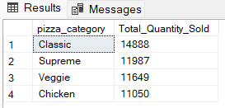

**G. Top 5 Pizzas by Revenue**

SELECT * FROM

(SELECT PIZZA_NAME,SUM(TOTAL_PRICE),COUNT(DISTINCT ORDER_ID) FROM PIZZA GROUP BY PIZZA_NAME

ORDER BY COUNT(DISTINCT ORDER_ID) DESC)

WHERE ROWNUM<=5

**OUTPUT**

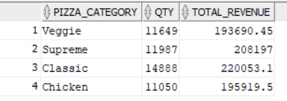

**H. Bottom 5 Pizzas by Revenue**

SELECT * FROM

(SELECT PIZZA_NAME AS BOOTOM_SALE_PIZZAS,SUM(TOTAL_PRICE)AS PRICE,COUNT(DISTINCT ORDER_ID)AS TOTAL_ORDERS FROM PIZZA GROUP BY PIZZA_NAME

ORDER BY COUNT(DISTINCT ORDER_ID)ASC)

WHERE ROWNUM<=5

**OUTPUT**

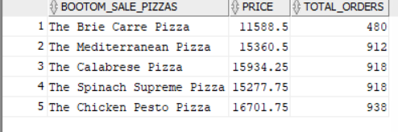

**I. Top 5 Pizzas by Quantity**

SELECT * FROM

(SELECT PIZZA_NAME,COUNT(QUANTITY)AS QTY FROM PIZZA GROUP BY PIZZA_NAME

ORDER BY COUNT(QUANTITY)DESC)

WHERE ROWNUM<=5

***Output***

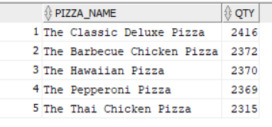

**J. Bottom5 Pizzas by Quantity**

SELECT * FROM

(SELECT PIZZA_NAME,COUNT(QUANTITY)AS QTY FROM PIZZA GROUP BY PIZZA_NAME

ORDER BY COUNT(QUANTITY)ASC)

WHERE ROWNUM<=5

***Output***

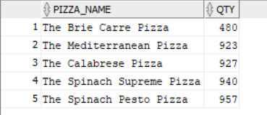

**K. Top 5 Pizzas by Total Orders**

SELECT * FROM

(SELECT PIZZA_NAME,COUNT(DISTINCT ORDER_ID) FROM PIZZA GROUP BY PIZZA_NAME

ORDER BY COUNT(DISTINCT ORDER_ID) DESC)

WHERE ROWNUM<=5

**OUTPUT**

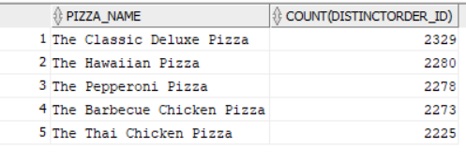

**L. Bottom 5 Pizzas by Total Orders**

SELECT * FROM

(SELECT PIZZA_NAME,COUNT(DISTINCT ORDER_ID) FROM PIZZA GROUP BY PIZZA_NAME

ORDER BY COUNT(DISTINCT ORDER_ID) ASC)

WHERE ROWNUM<=5

**OUTPUT**

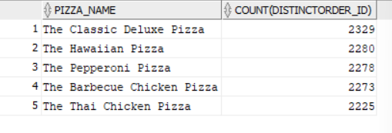

***NOTE***

If you want to apply the pizza_category or pizza_size filters to the above queries you can use WHERE clause. Follow some of below examples

SELECTTop 5 pizza_name,COUNT(DISTINCT order_id)AS Total_Orders

FROM pizza_sales

WHERE pizza_category ='Classic'

GROUPBY pizza_name

ORDERBY Total_Orders ASC

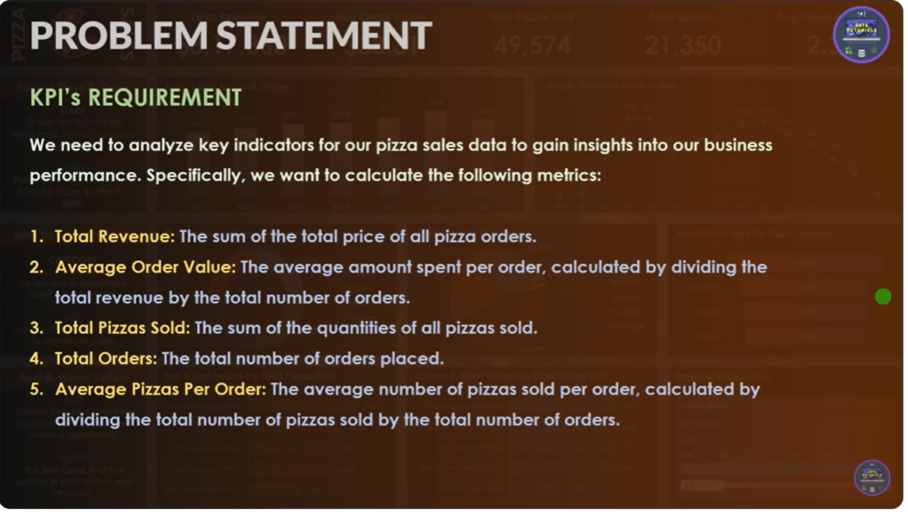

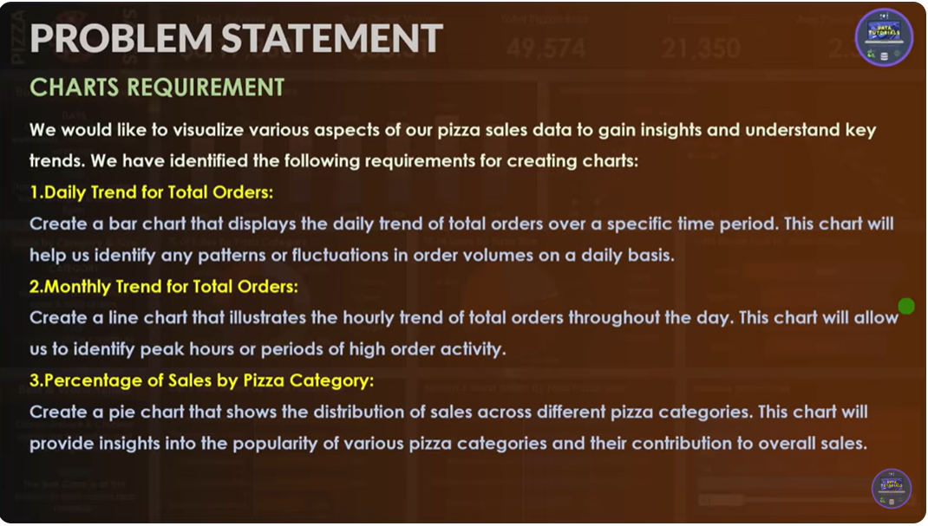

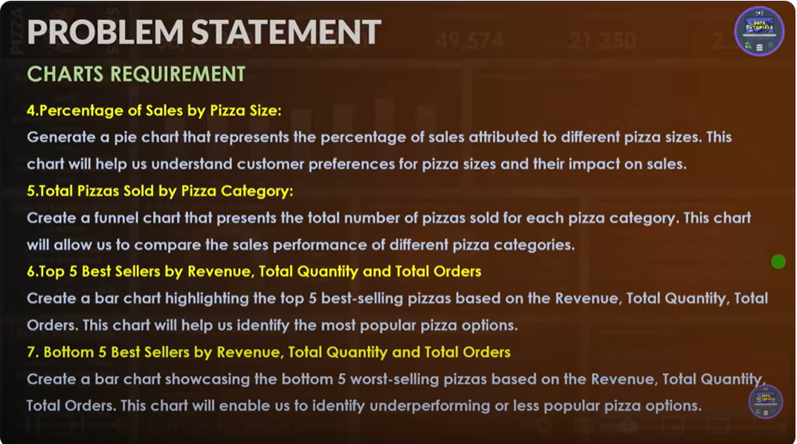

**1. select * from pizza**

**2. select sum(total_price) AS TOTAL_REVENUE FROM pizza**

**3. select (sum(total_price)/count(distinct order_id)) as average_order_value from pizza**

**4.select sum(quantity) as Total_pizzas_sold from pizza**

**5.select count(distinct order_id) as total_orders from pizza**

**6.select cast(sum(quantity)/count(distinct order_id)as decimal(10,2)) as average_pizzas_per_order from pizza**

**7.SELECT TO_CHAR(ORDER_DATE,'DY') AS DAYS ,COUNT(DISTINCT ORDER_ID)AS ORDERS FROM PIZZA GROUP BY TO_CHAR(ORDER_DATE,'DY')**

**ORDER BY COUNT(DISTINCT ORDER_ID) ASC**

**8.SELECT to_char(order_date,'MON')AS MONTHS,COUNT(DISTINCT ORDER_ID) AS ORDERS FROM PIZZA GROUP BY to_char(order_date,'MON')**

**ORDER BY COUNT(DISTINCT ORDER_ID) ASC**

**9.SELECT PIZZA_CATEGORY,SUM(TOTAL_PRICE)AS TOTAL_REVENUE,**

**CAST(SUM(TOTAL_PRICE)*100/(SELECT SUM(TOTAL_PRICE) FROM PIZZA)AS DECIMAL(10,2))AS PERCENTAGE**

**FROM PIZZA GROUP BY PIZZA_CATEGORY**

**10.SELECT PIZZA_SIZE,SUM(TOTAL_PRICE)AS PRICE,CAST(SUM(TOTAL_PRICE)*100/(SELECT SUM(TOTAL_PRICE)FROM PIZZA)AS DECIMAL(10,2)) AS PERCENTAGE**

**FROM PIZZA GROUP BY PIZZA_SIZE**

**11.SELECT PIZZA_CATEGORY,SUM(QUANTITY)AS QTY,SUM(TOTAL_PRICE) AS TOTAL_REVENUE FROM PIZZA GROUP BY PIZZA_CATEGORY**

**ORDER BY PIZZA_CATEGORY DESC**

**12.SELECT * FROM**

**(SELECT PIZZA_NAME,SUM(TOTAL_PRICE),COUNT(DISTINCT ORDER_ID) FROM PIZZA GROUP BY PIZZA_NAME**

**ORDER BY COUNT(DISTINCT ORDER_ID) DESC)**

**WHERE ROWNUM<=5**

**13.SELECT * FROM**

**(SELECT PIZZA_NAME AS BOOTOM_SALE_PIZZAS,SUM(TOTAL_PRICE)AS PRICE,COUNT(DISTINCT ORDER_ID)AS TOTAL_ORDERS FROM PIZZA GROUP BY PIZZA_NAME**

**ORDER BY COUNT(DISTINCT ORDER_ID)ASC)**

**WHERE ROWNUM<=5**

**14.SELECT * FROM**

**(SELECT PIZZA_NAME,COUNT(QUANTITY)AS QTY FROM PIZZA GROUP BY PIZZA_NAME**

**ORDER BY COUNT(QUANTITY)DESC)**

**WHERE ROWNUM<=5**

**15.SELECT * FROM**

**(SELECT PIZZA_NAME,COUNT(QUANTITY)AS QTY FROM PIZZA GROUP BY PIZZA_NAME**

**ORDER BY COUNT(QUANTITY)ASC)**

**WHERE ROWNUM<=5**

**16.SELECT * FROM**

**(SELECT PIZZA_NAME,COUNT(DISTINCT ORDER_ID) FROM PIZZA GROUP BY PIZZA_NAME**

**ORDER BY COUNT(DISTINCT ORDER_ID) DESC)**

**WHERE ROWNUM<=5**

**17.SELECT * FROM**

**(SELECT PIZZA_NAME,COUNT(DISTINCT ORDER_ID) FROM PIZZA GROUP BY PIZZA_NAME**

**ORDER BY COUNT(DISTINCT ORDER_ID) ASC)**

**WHERE ROWNUM<=5**